**NAME:MUHAMMAD SHAF HAMEED**

**WORKSTATION :3**

TASK NO:8

LOGICLY:

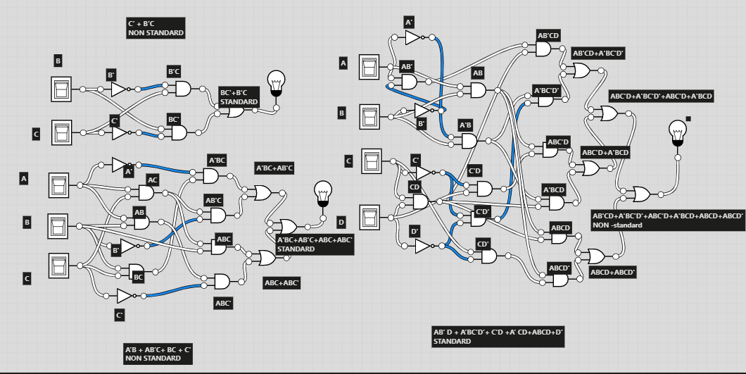

**TINKERCAD:**

**EQUATION1: C’ + B’C**

**MINIMIZED B’+C’**

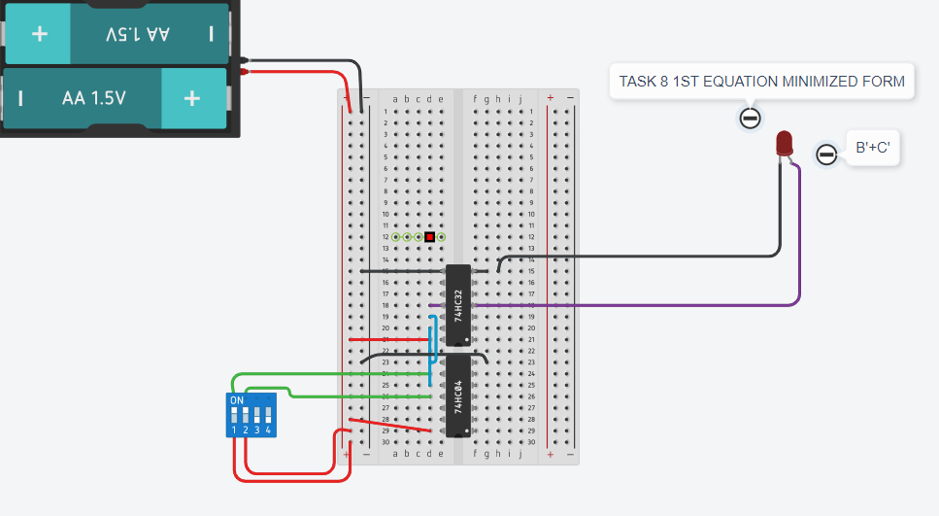

**EQUATION2: A’B + AB’C+ BC + C’**

**MINIMIZED B+B’C’**

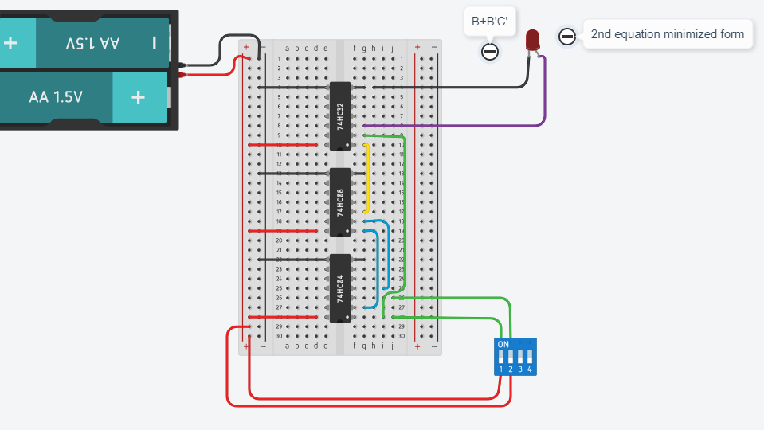

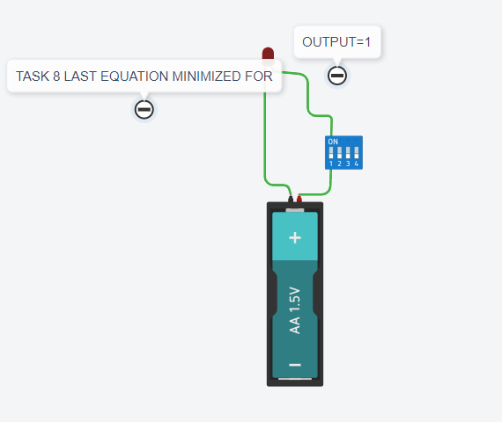

**EQUATION2: AB’ D + A’BC’D’+ C’D +A’ CD+ABCD+D’**

**MINIMIZED 1**